**Q1) Create a blog for advertising your brand and publish it.**

**Steps:**

1. Open a Blogger.com website for posting your blog <https://www.blogger.com/about/?bpli=1>
2. Click on the “Create Your Blog” button and sign up with your email.
3. After that choose a name for Your blog and click on Next
4. choose the URL for your blog and click on next.
5. Enter name for Your blog and click on Finish
6. Click on New Post
7. Start your blog with the Title, Main Content and Conclusion.

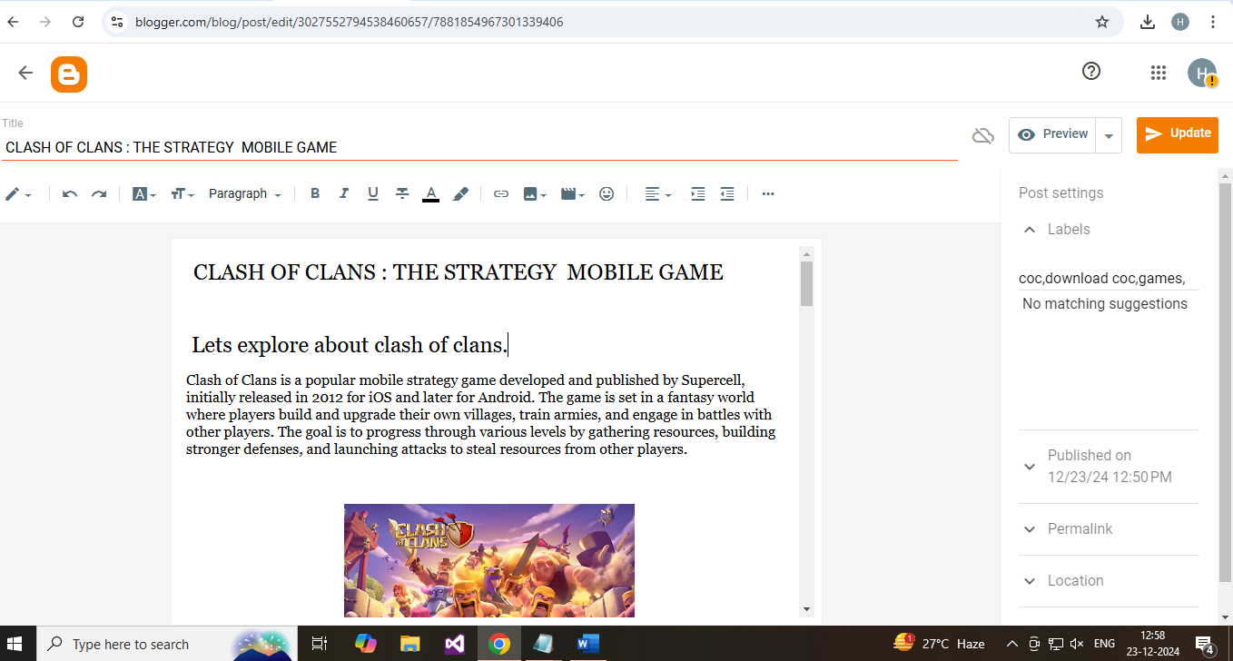

1. You can format your text you multiple formatting option. Like Make Heading, Subheading your Text. You can make bold, italic & underline to your text.
2. After that you can insert Images and videos in your blog. You can Insert Links 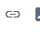 using this option. Click on link tab it will appear new pop-window.
3. To add a video, click on the 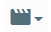 icon. The popup menu shows 2 options, one for inserting through your device and other for uploading through youtube.
4. Text to display your link name which you paste & Paste link in your paste or search for a link. And choose to open this link in a new window means it will move to new page or add rel=nofollow attribute means it will appear in this same page and click on Apply.
5. After that you can set label for keywords that help user to find the blog, set the date and time for publish, permalinks (your blog link), location and option for comment (allow and don’t depend on you)
6. Before Publish you can preview your blog in multiple devices like phone, tablet, desktop etc. If it is perfect, then publish by clicking on publish button.

Blog link:

<https://clashofclq.blogspot.com/2024/12/clash-of-clans-strategy-mobile-game.html>

Blog: 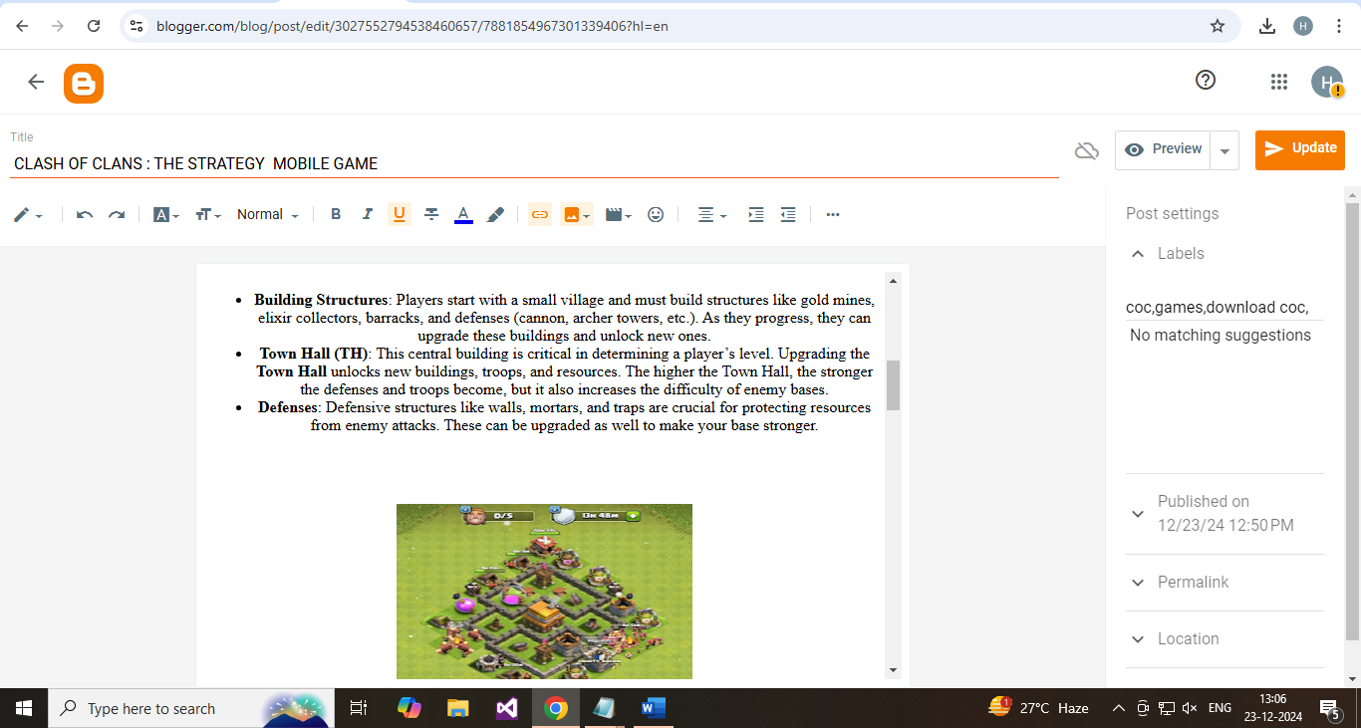

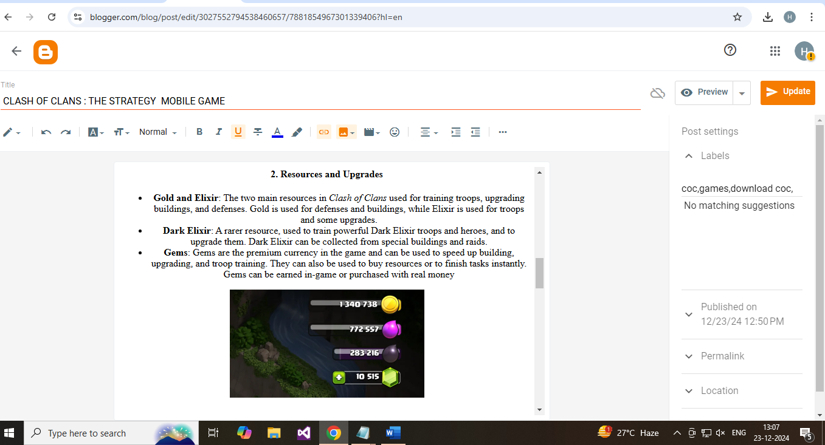



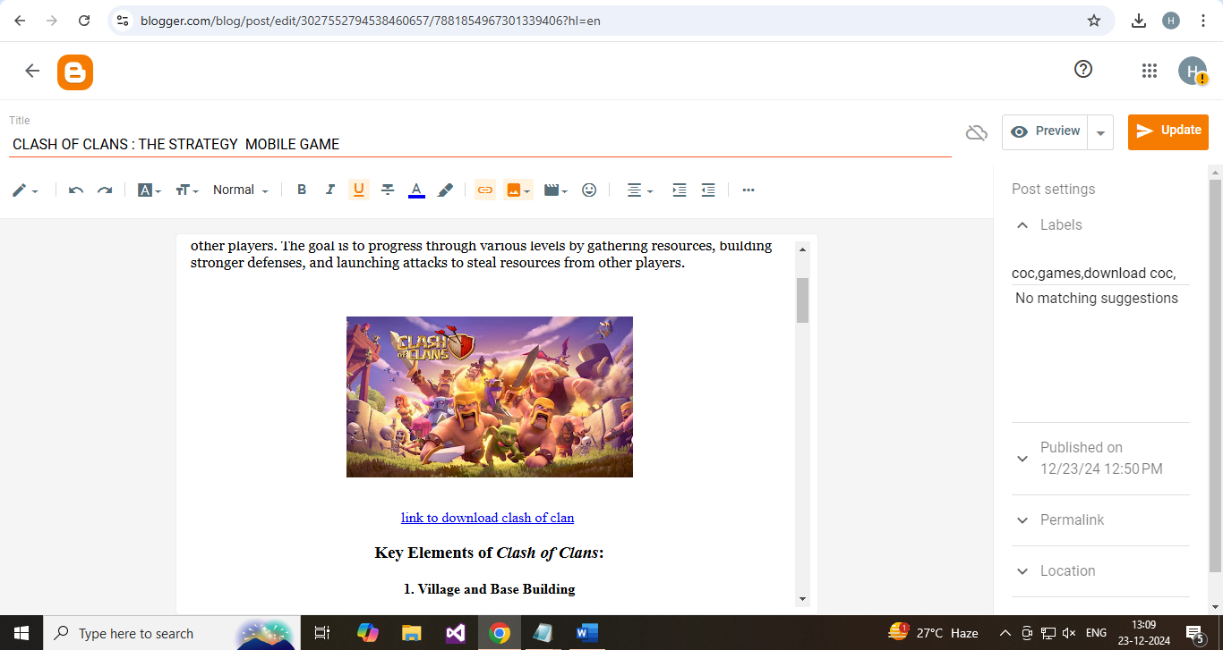

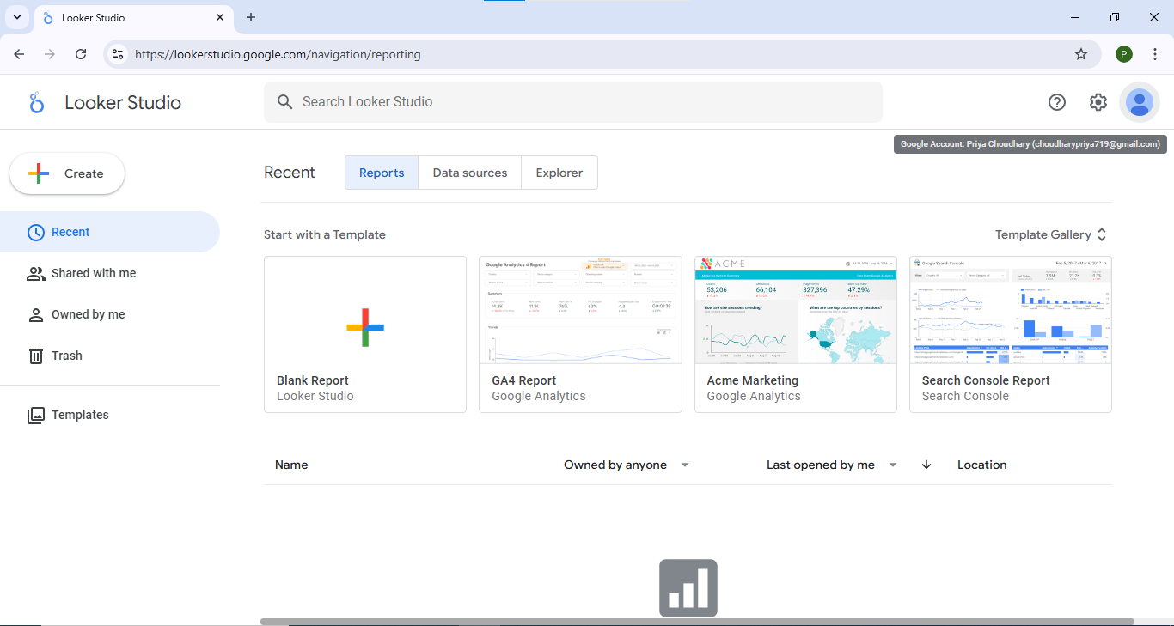

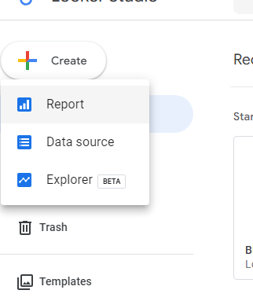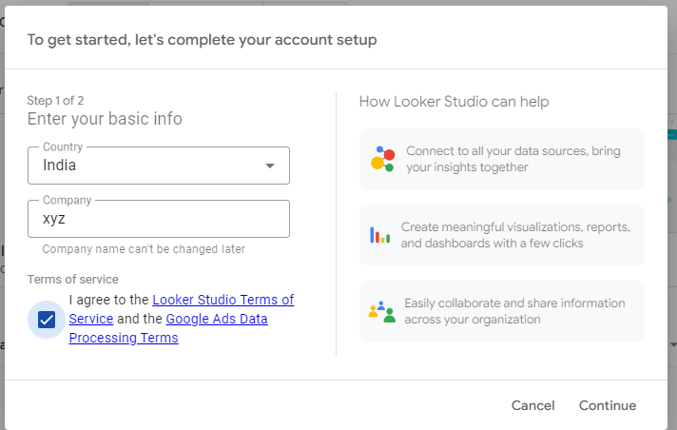

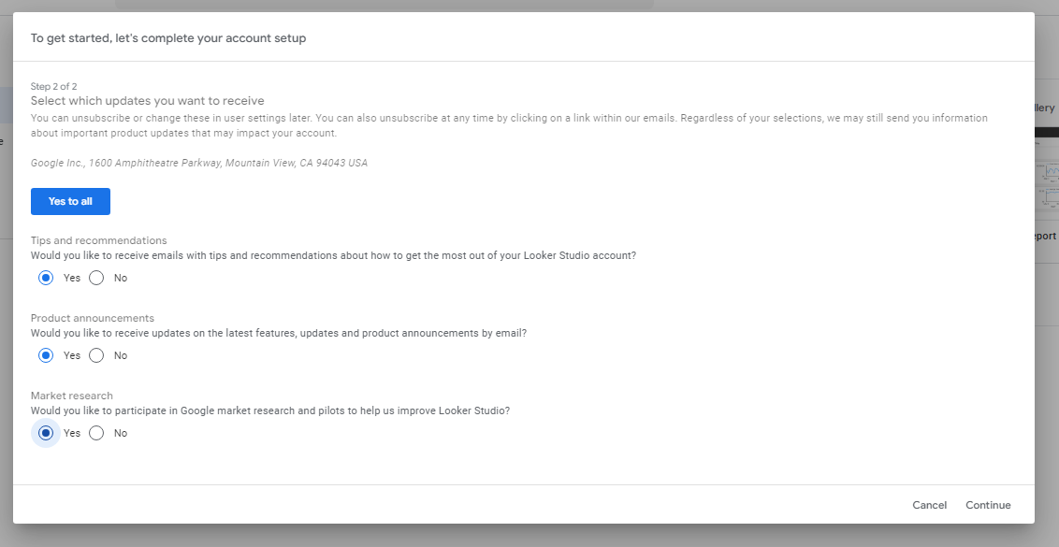

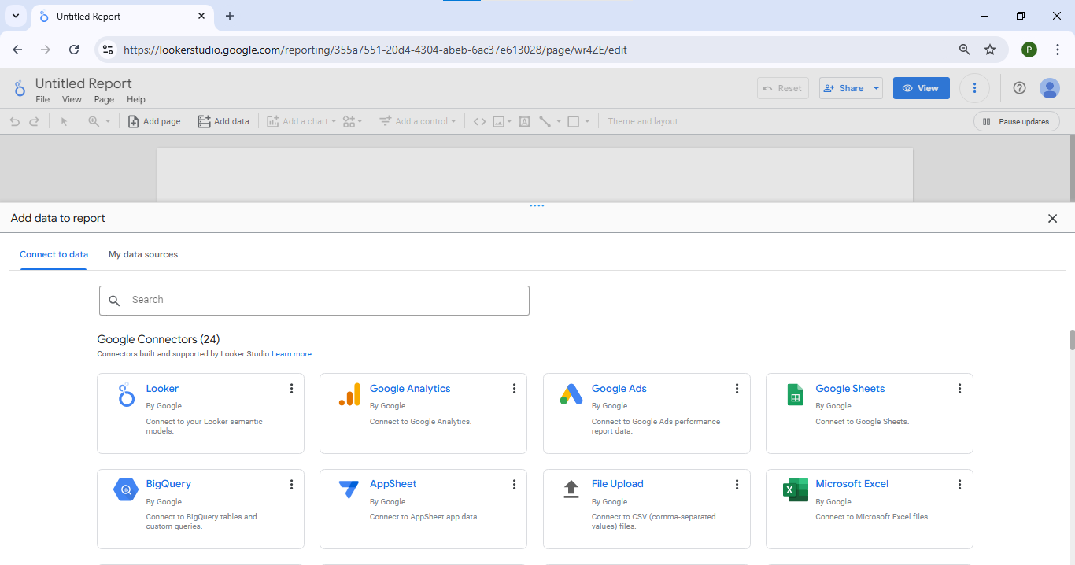

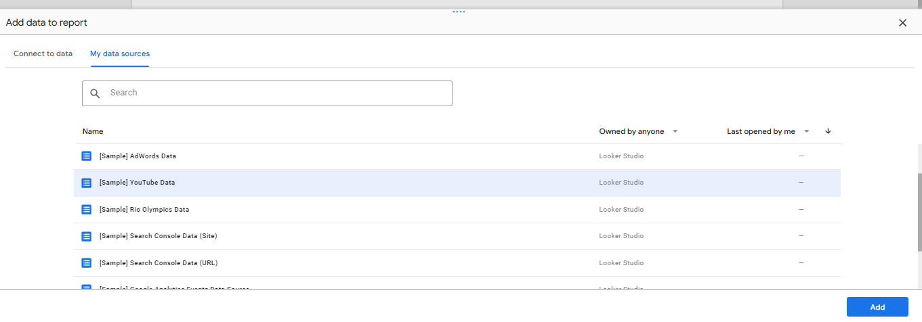

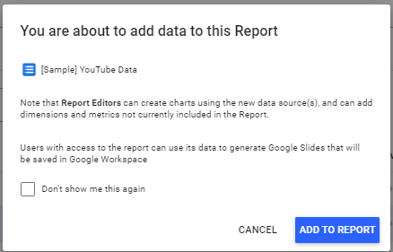

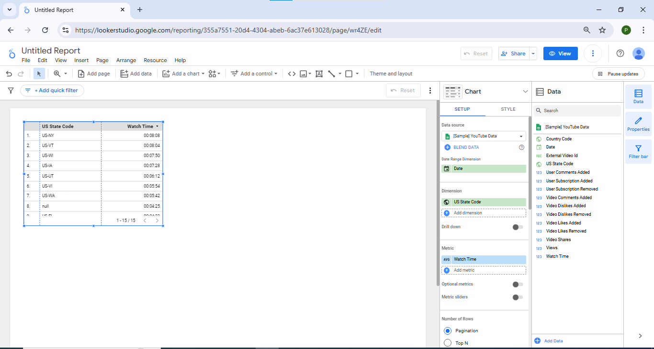

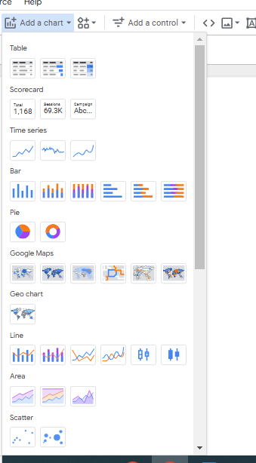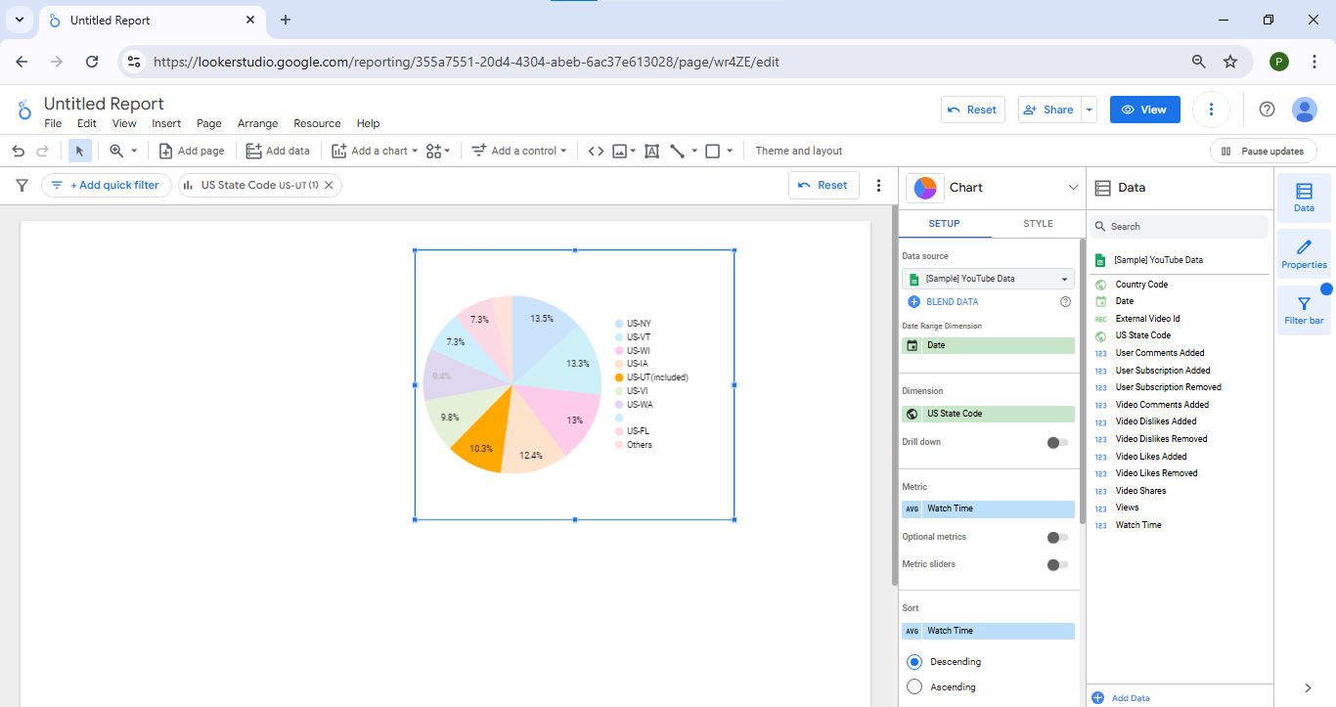

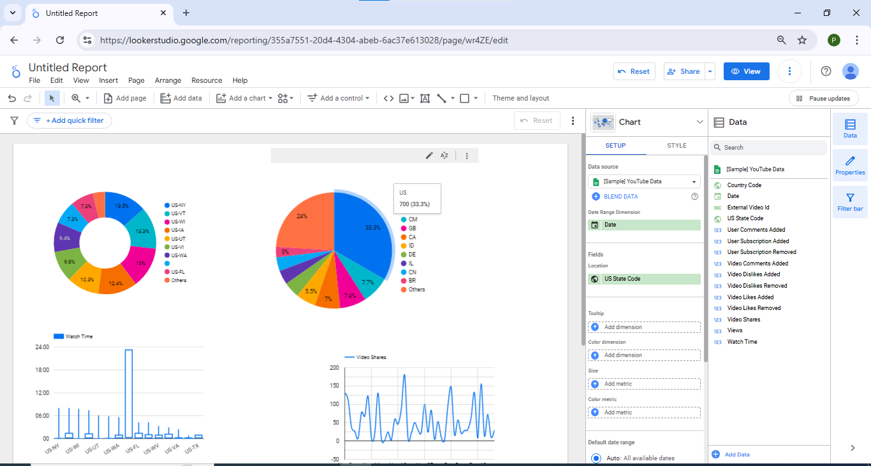

<https://lookerstudio.google.com/reporting/355a7551-20d4-4304-abeb-6ac37e613028/page/wr4ZE/edit>

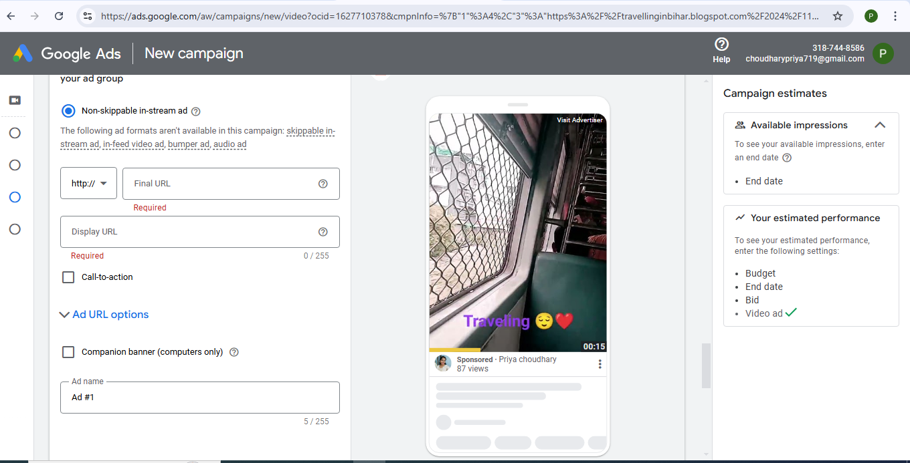

**Q1 ) Demonstrate the use of Google Analytics tools such as Data studio.**

**Looker Studio:**

Looker Studio is a free, web-based tool that helps users create and share interactive dashboards and reports.  Looker is a popular business intelligence tool because of the way it integrates with Google Cloud and its impressive data modeling functions. Customers note the platform's easy-to-use interface, seamless integration with data sources, and drag-and-drop feature.

**Steps:**

1. Search Looker Studio in Search bar and open Looker Studio. Link ( :https://lookerstudio.google.com/navigation/reporting )
2. Click on Create in that mutilple option such as report, data source and Explore apper in that click report option.
3. After that pop-window will appear such account setup fill the corresponding details such as country, company name etc. and click on continue after that conformation appear in that click on yes and click on continue.
4. After that Add Data to report page open in that go to My data sources click on any one data such as Youtube Data and click on Add.
5. Now one pop window will appear that You are about to add data to report in that click Add to Report.
6. And then Table will apper for your data -> delete table -> Add a chart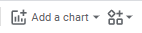 -> In that select Any Five Chart. With respective dimension and metric.

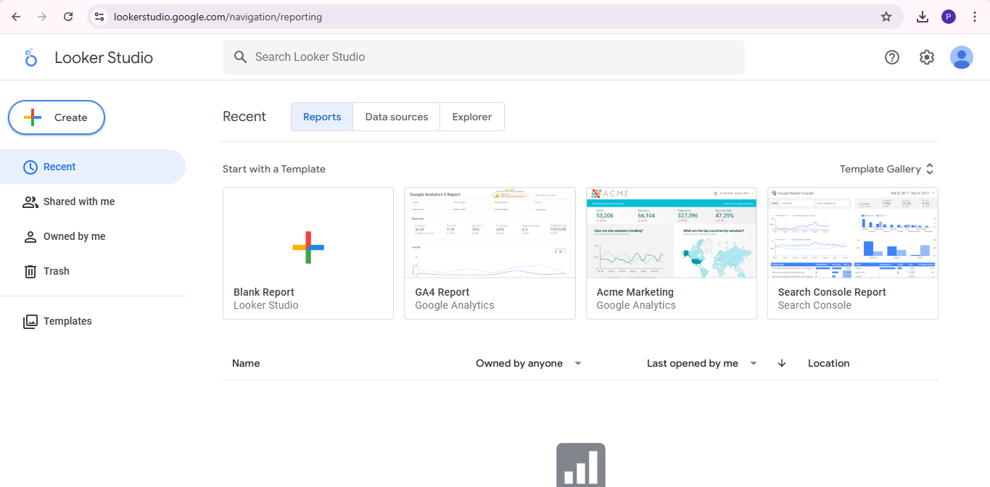



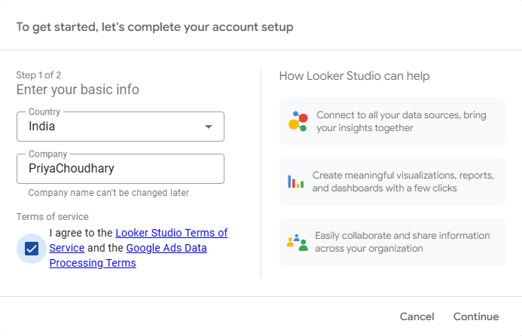



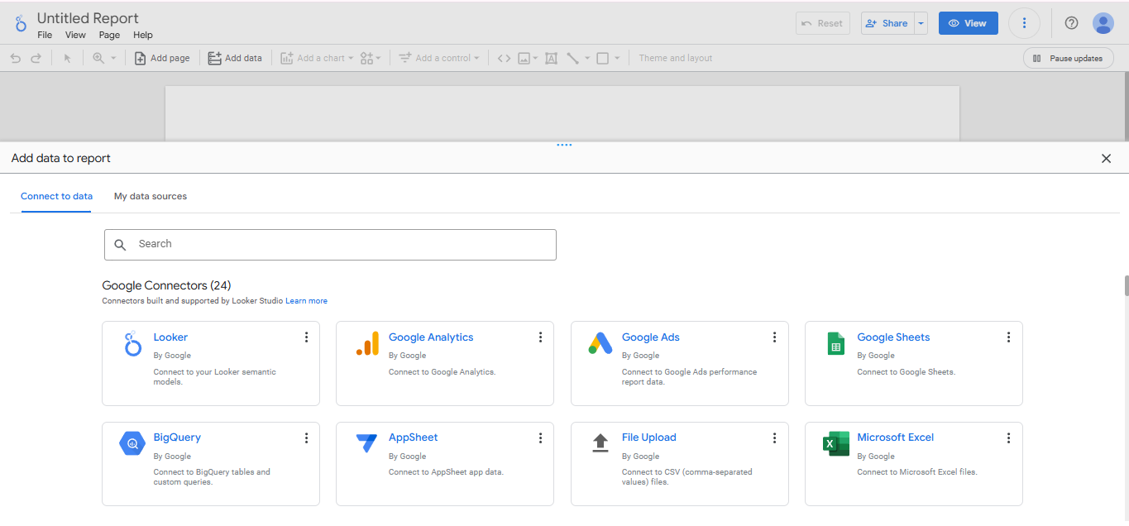

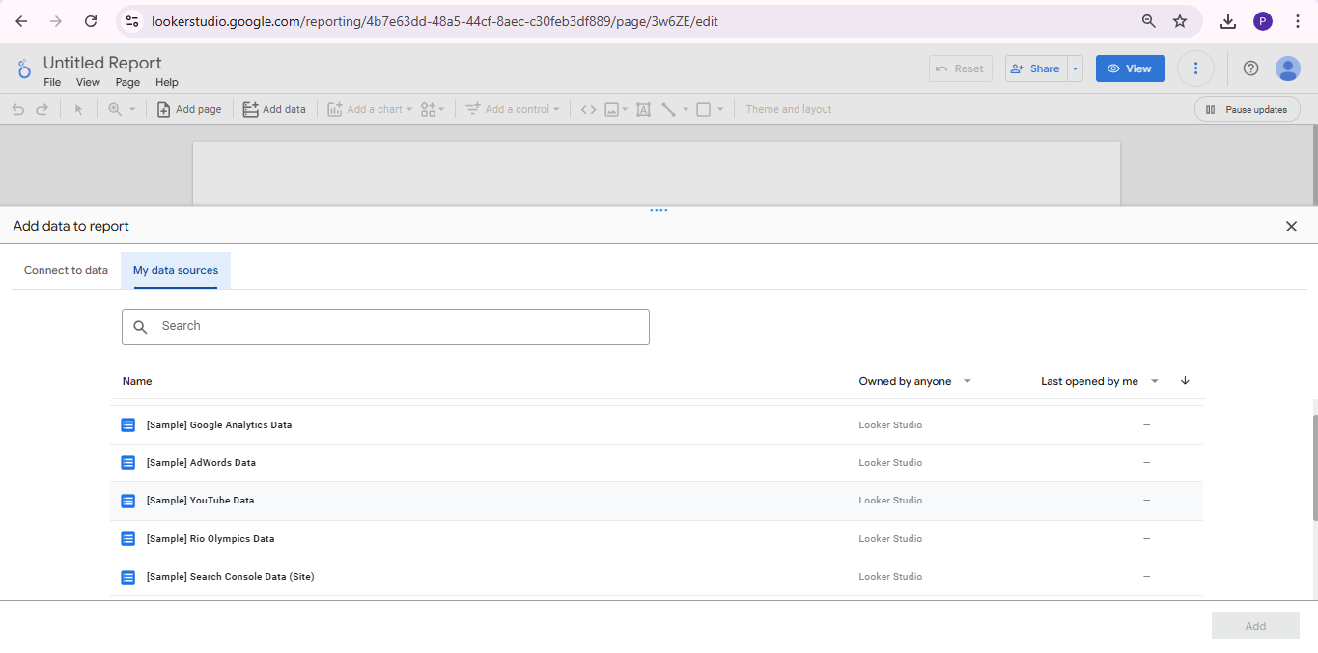

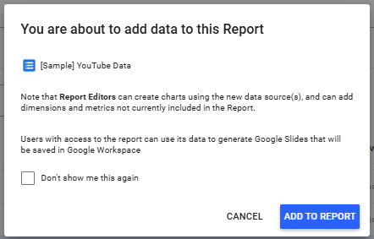

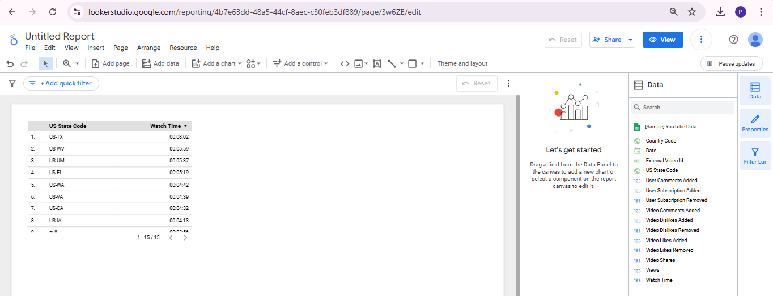



1. Pie Chart (Dimension: Country Code And Metrics: Views)

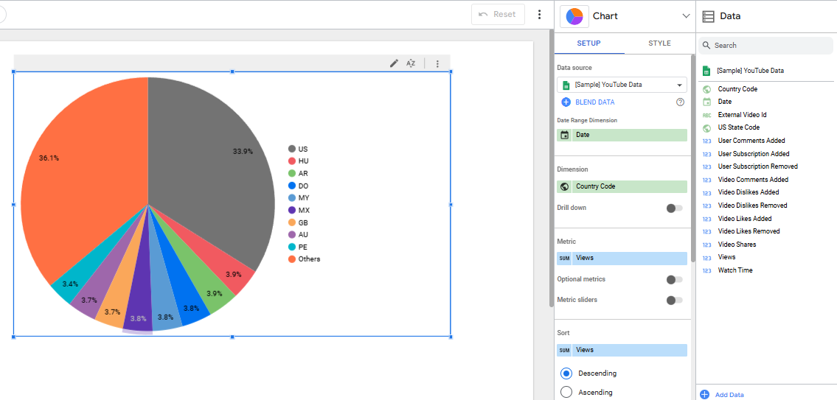

1. Stacked Column Chart (Dimension: Country Code And Metrics: Video Share)

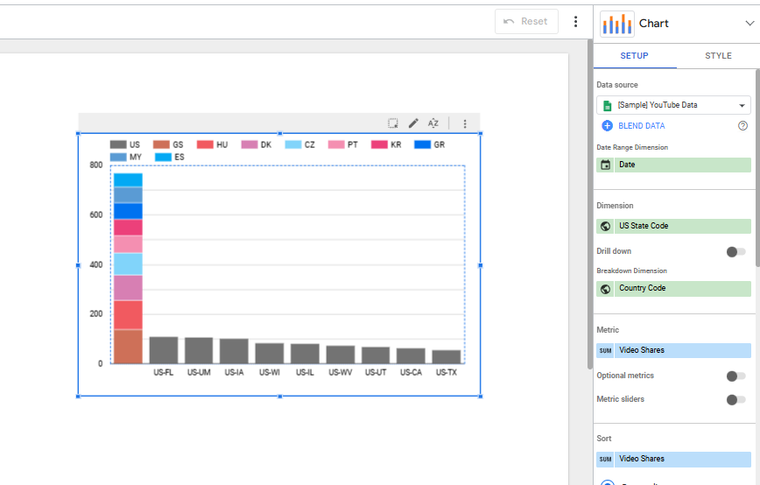

1. Candlestick Chart (Dimension: Country Code And Metrics: Watch Time)

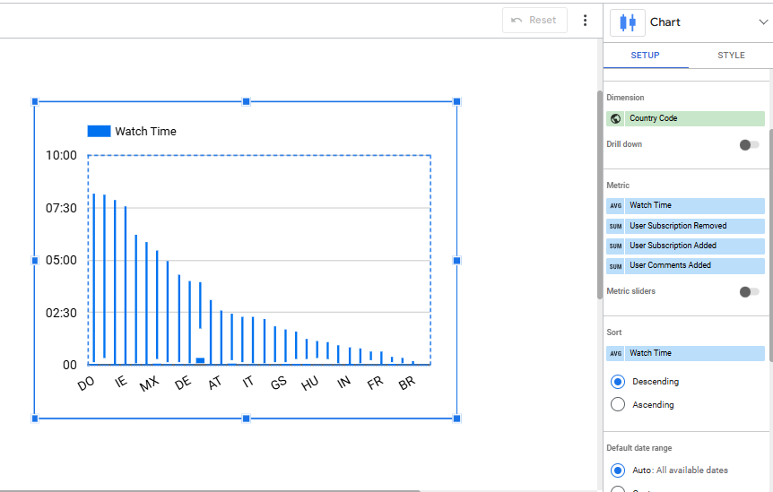

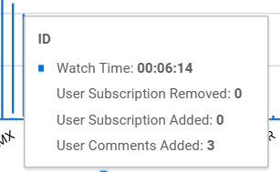

1. Scatter Chart (Dimension: USA State Code And Metrics: Watch Time and Video Like Added)

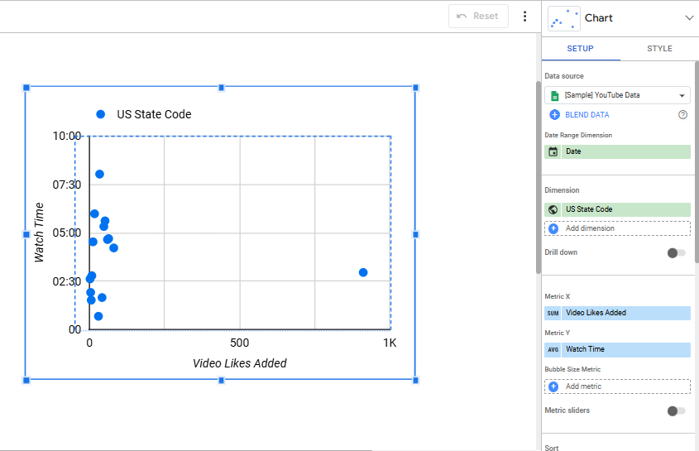

1. Time Series Chart (Dimension: Date And Metrics: Watch Time)

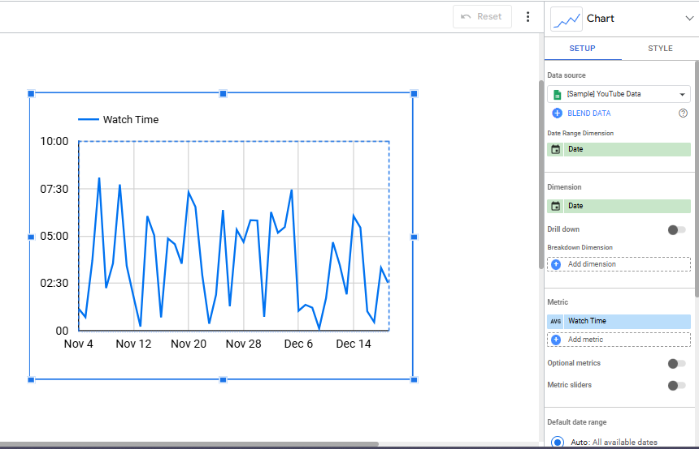

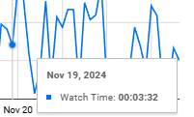

Q1) Demonstrate the use of Google Analytics tool such as Google Adz.

**Google Adz:**

Google Ads is a product that you can use to promote your business, help sell products or services, raise awareness, and increase traffic to your website. Google Ads accounts are managed online, so you can create and change your ad campaign at any time, including your ad text, settings, and budget. Google search sites: Ad can appear above or below search results on Google Search. They can appear beside, above, or below search results on Google Play, in the Shopping tab, and Google Maps, including the Maps app.

Steps :

1. Search Google Adz on Search bar and Open Google Adz (<https://ads.google.com/home/>)
2. Click on Start Now. After that one pop- window will appear in that click on Create your first Campaign.
3. Now setting up your Campaign such as company name and provide your company blog url and click on next and it asking more account to link Skip if you want to or add account (such as Mobile app, phone number and Google business profile) etc. and click on next.
4. After that it provide choose your goal for this Campaign. (Brand awareness) and click on Next. And choose a Campaign type such as youtube, display and search etc. and click on next. Set your Campaign setting such as location and language and click on next. After that set your buget ( in budget and binding window).
5. New Window appear such as Targeting in that click on Add targeting in that set audience, demographic and keywords etc after that click on next.
6. In keyword set the keyword revalent to your website you can click on “+” option to add keyword for your ads. After that click on next option.
7. After that it open your Ads window and in that set your business name add images, logos, videos headline , long-headline and description etc and it will show in your display section click on next.
8. You can add a Campaign type as Youtube also in place of display and select a campaign subtype (video reach) and select the way you would like to reach it (skippable and non-skippable video).
9. After that Create your video ads in that select a youtube video and it will show how it will look like that.

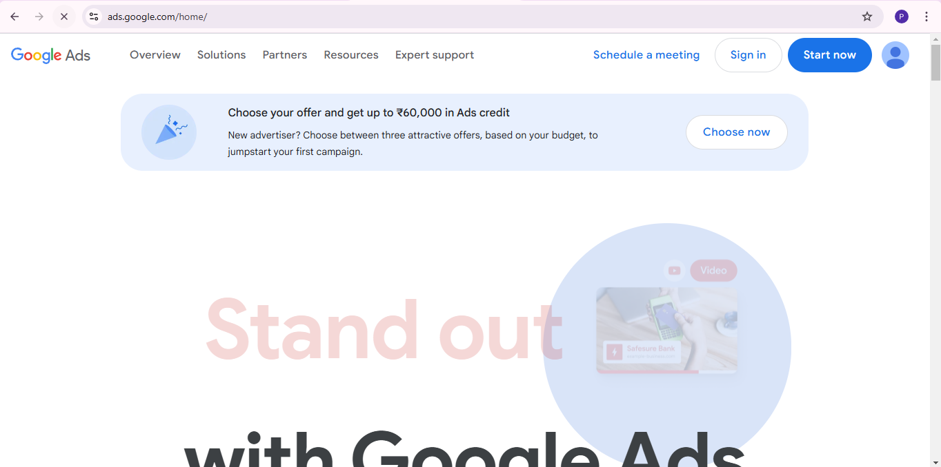

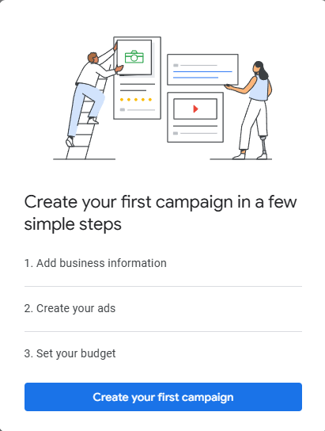

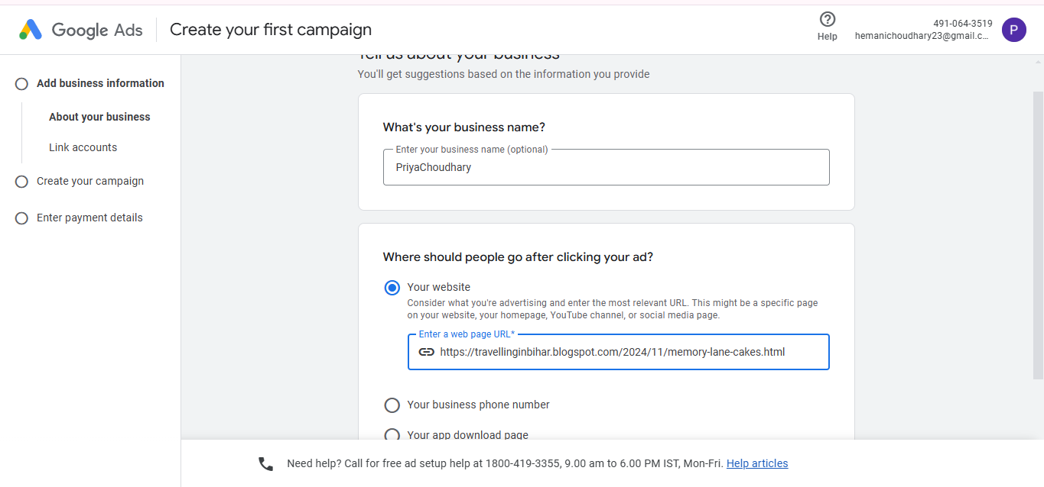

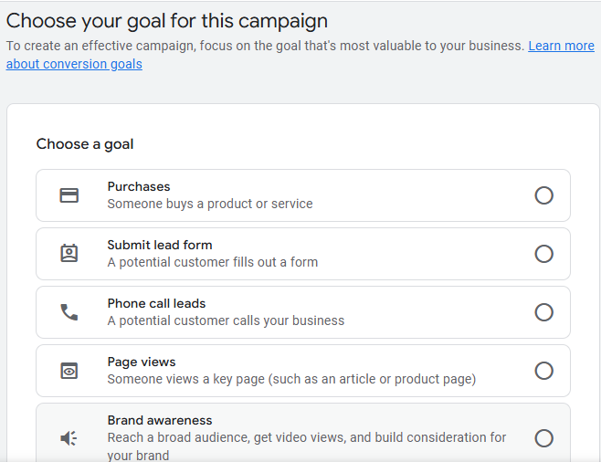

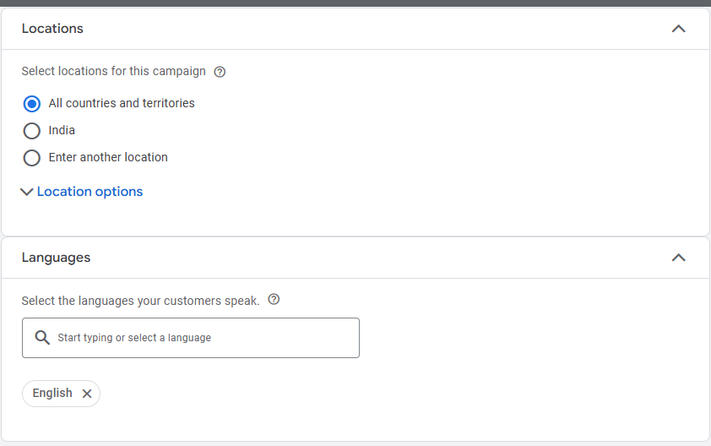

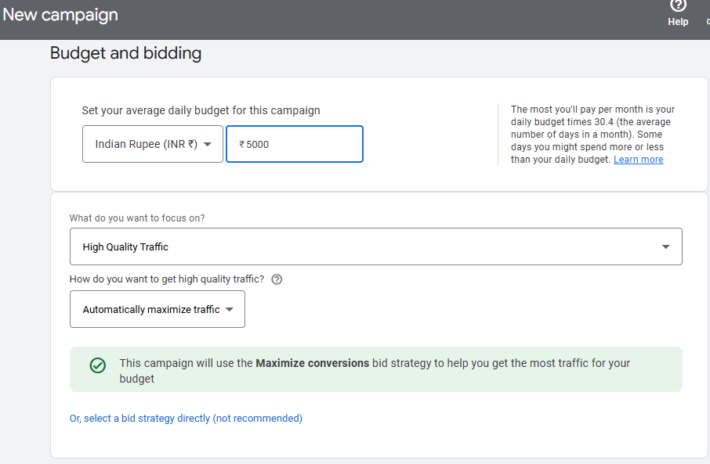

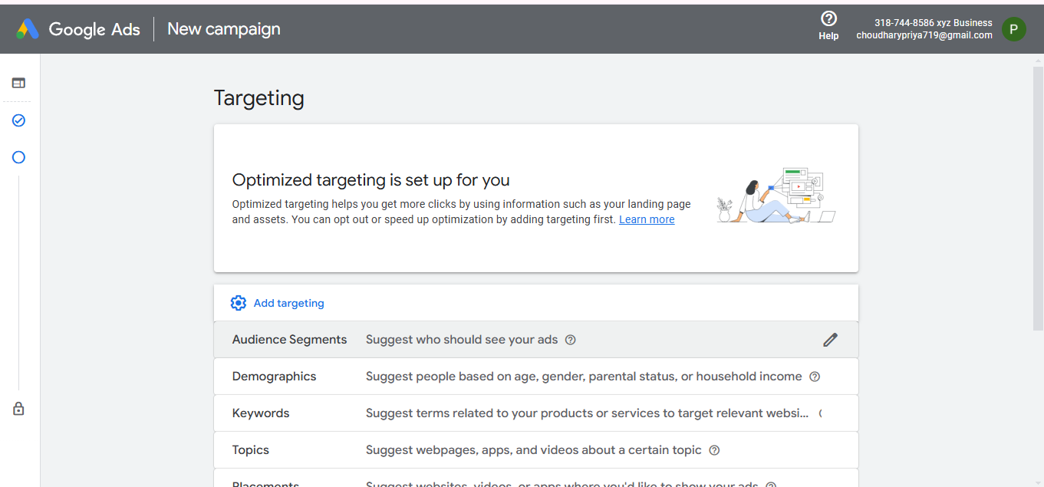

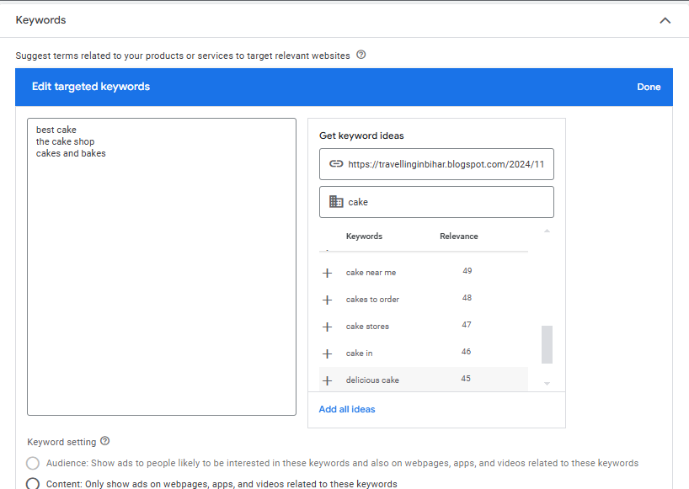

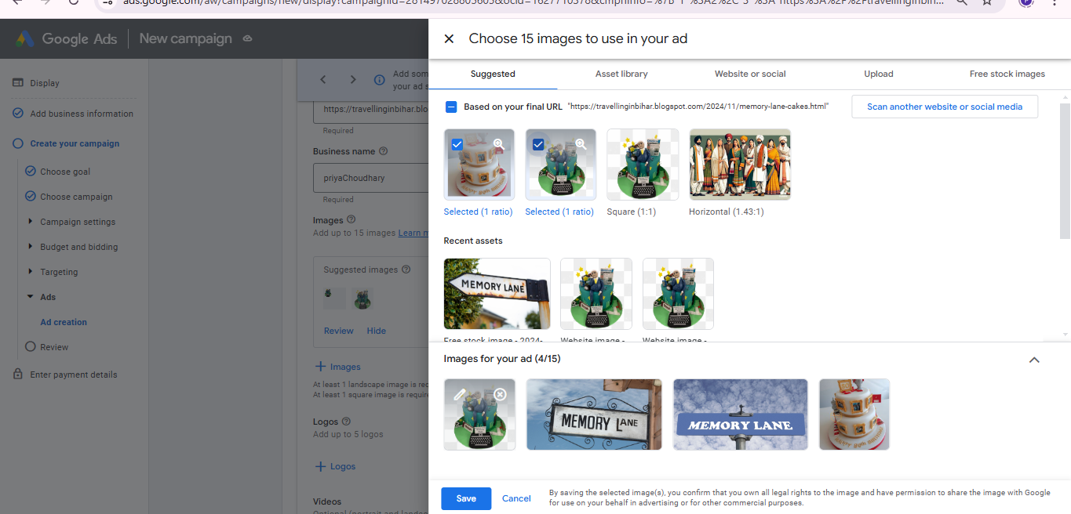

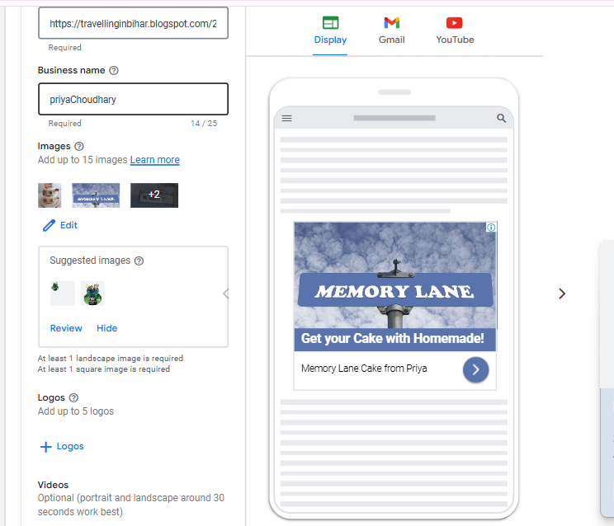

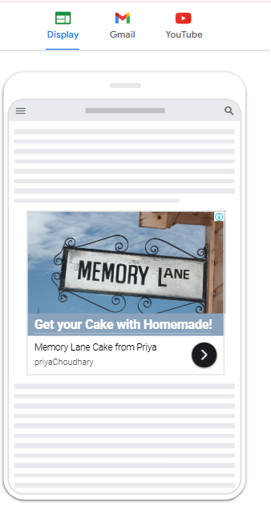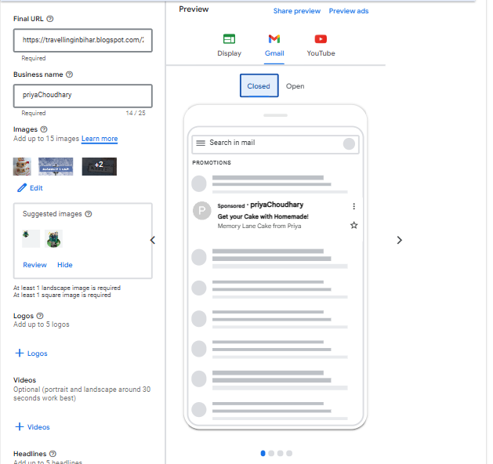

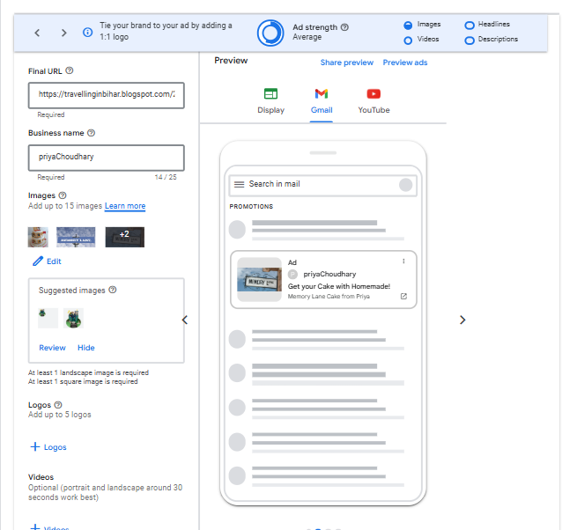

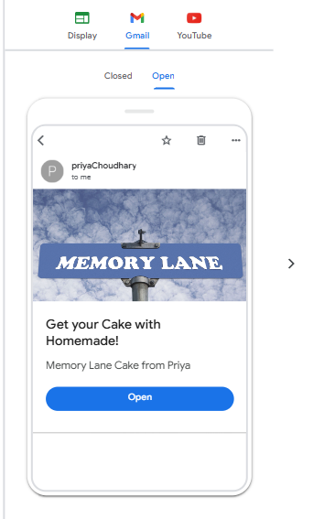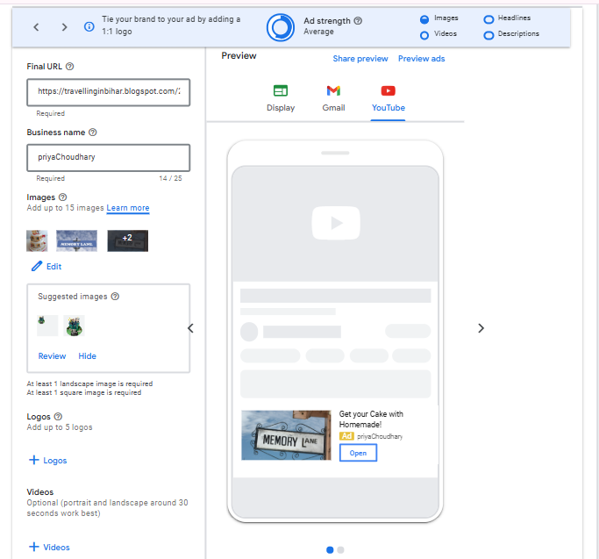

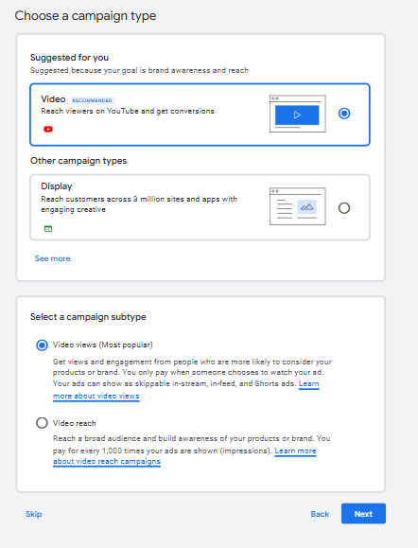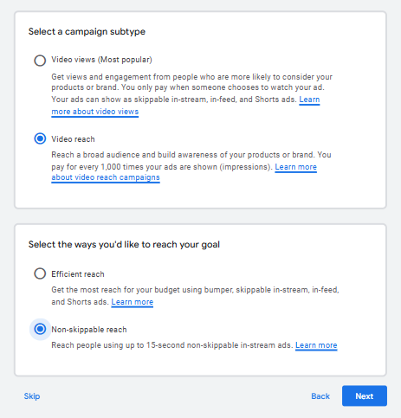

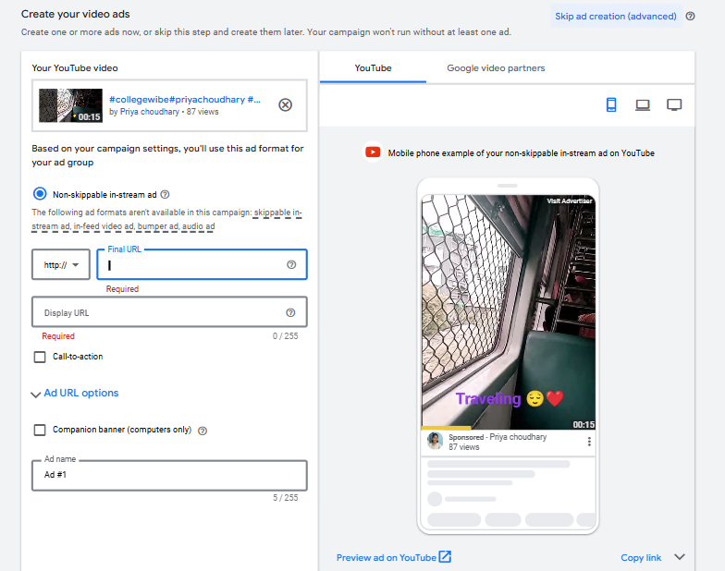

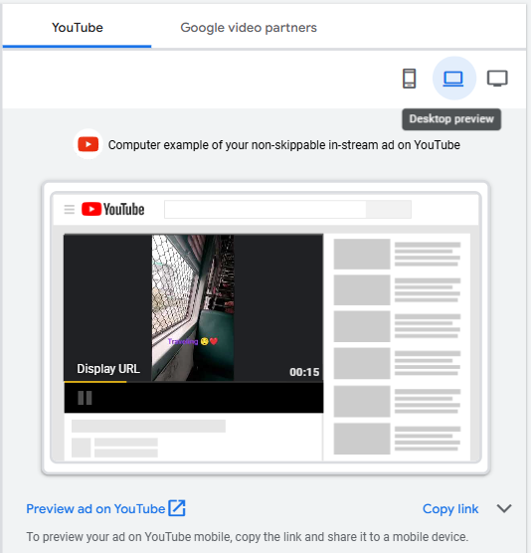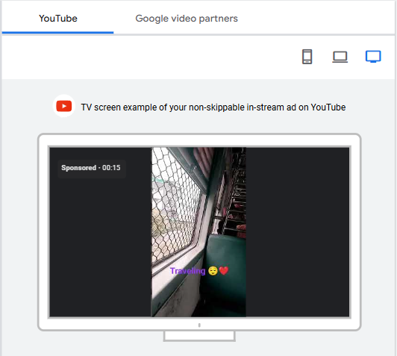

Q1) Demonstrate the use of Google AdWords.

Aim: Demonstrate the usage of keyword research tool Semrush

Semrush:

[Semrush](https://www.semrush.com/dashboard/) is an all-in-one tool suite for improving online visibility and discovering marketing insights. Our tools and reports can help marketers with the following services: SEO, PPC, SMM, Keyword Research, Competitive Research, PR, Content Marketing, Marketing Insights, and Campaign Management.

Steps:

1. Open Semrush Website on google & Signup with your email and password.
2. Customize your flow by felling some basic details and click on continue button.
3. Its open main page of semrush in that paste your blog website and click on start now.
4. After that go to Left bar side in that select keyword Overview in that enter your keyword that is used in your blog and select the location such as India and click on Search. For example, in my post it is used cake keyword.
5. After successfully analyse your keyword go to Keyword Gap which available on SEO Dashboard Left side of Bar.
6. In that compare two or more url related to your blog and compare & view the data.

**Keyword Overview:**

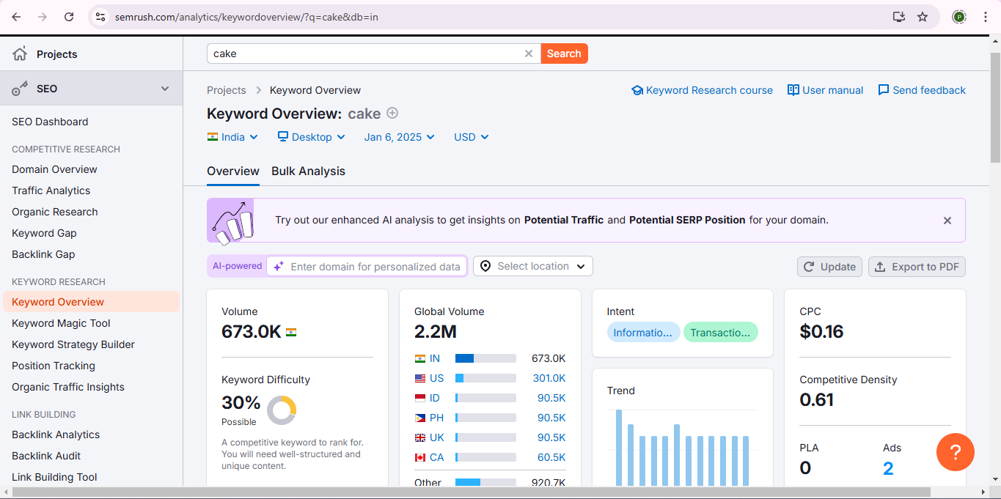

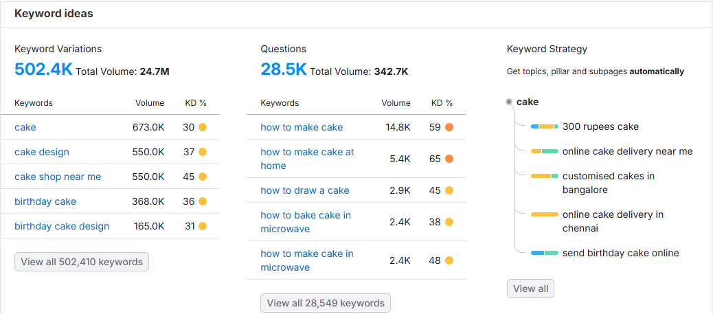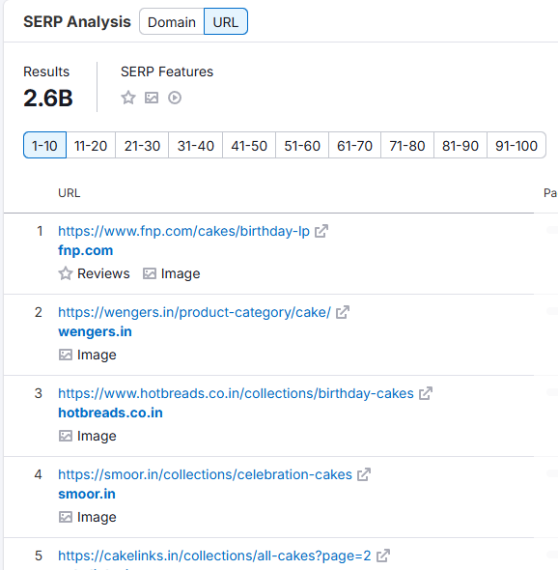

**Keyword Gap:**

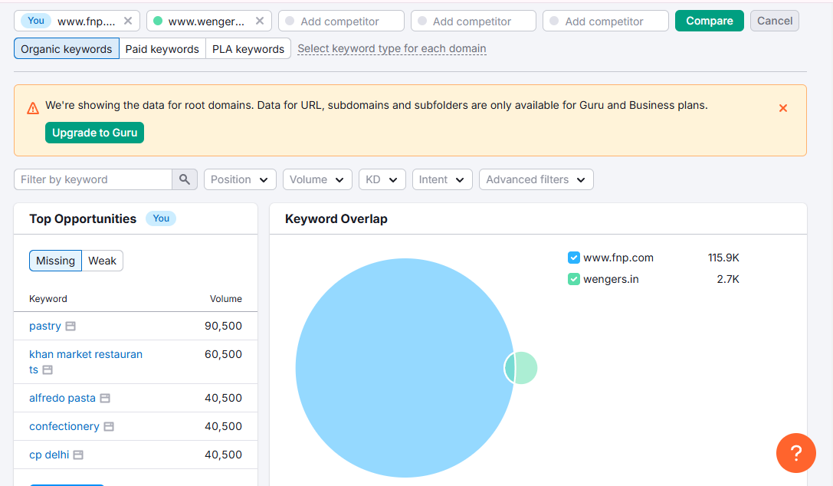

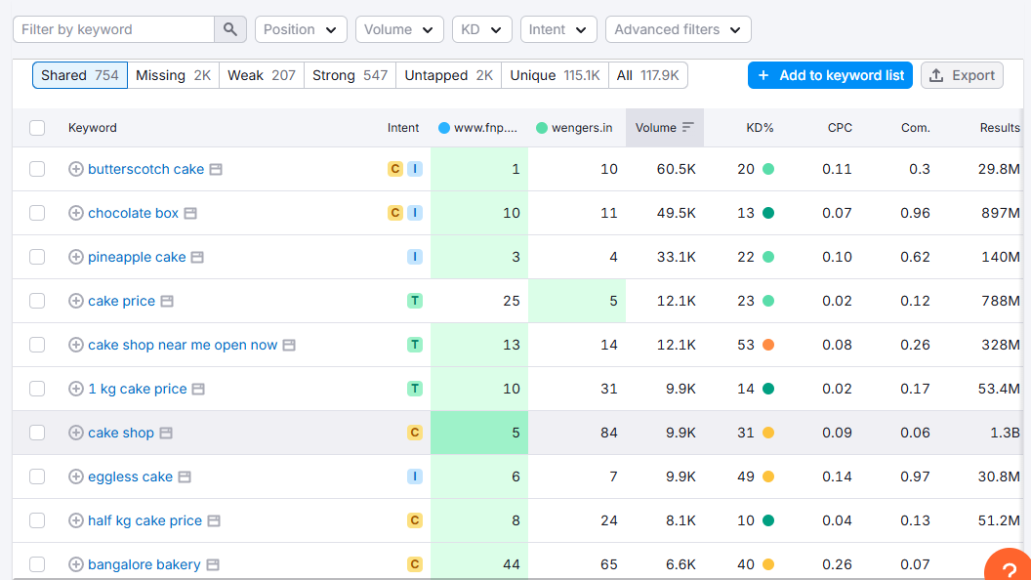

Q1) Demonstrate the Use of Google Analytics

**Google Analytics:**

Google Analytics is a tool that helps businesses understand how users interact with their websites and apps. It provides insights into user behavior, traffic sources, and more.

**Steps:**

1. Open the Google Analytics Login Page & Login with Your Google Account
2. It Open A Welcome Page and Click on Start Measuring.
3. It Open A create an Account such as Account Details such as Account Name and Click on Next.
4. After that It opens a Create a Property such as Property details such as Property Name and Reporting Time Zone such as India and it’s Currency and Click on Next.
5. It open Describe your Business such as Industry Category and Business Size and click on Next.
6. After that it open Choose your Business Objectives such as Leads, Sales, Traffic, User Engagement & rentation and other option to click particular all or click on other option to automatically click on all option.
7. Click on Create Option It provides terms accept and click on Next.
8. It open Data Collection (start Collecting Data) from web, Android and IOS click on Web and click on next .
9. It Open Set up Data Stream such as your Website (Blog) Url travellinginbihar.blogspot.com/2024/11/memory-lane-cakes.html and Stream Name MemoryLaneCake and Click on Create and Continue.
10. It will Open Google Data tab in that you will find a Javascript code copy the code and go to Blog in that click on Themes->customize->Edit Html -> Head tag paste code and click on Save
11. Now go to Google Analytics it will show the information regarding your blog such no of viewer visit your blog and all information regarding .

**Output:**

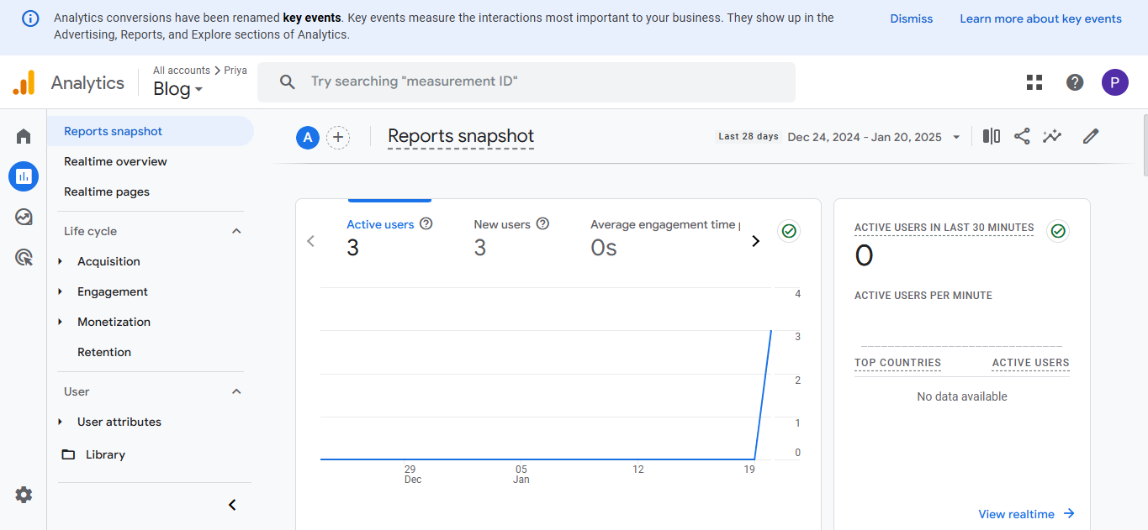

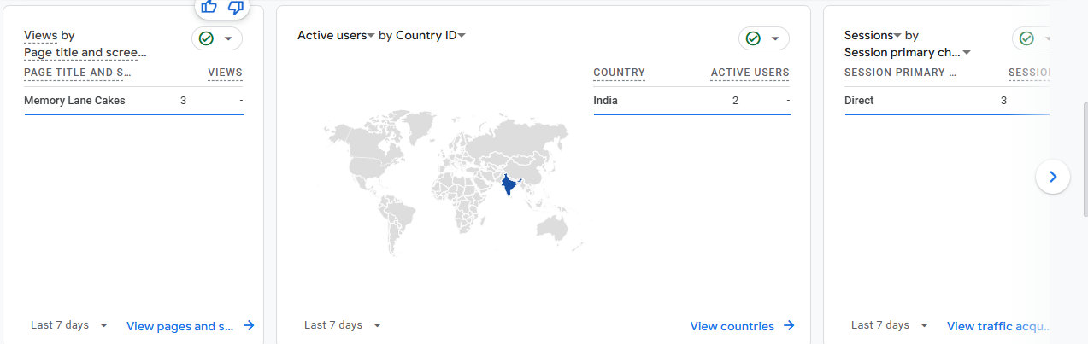

Q1) Demonstrate the use of Google Analytics for A/B testing

A/B Testing:

A/B testing, also called split testing, is a method where you compare two different versions of a webpage, email, or other digital element to see which one performs better based on a specific metric.

Steps:

1. Sign in to Google Sites

Go to [Google Sites](https://sites.google.com/).

Click on the **"+"** (Create a new site) button.

2. Choose a Template or Start Blank

Google Sites offers pre-designed templates, or you can start with a blank site.

Select a template that fits your needs or choose a blank one for full customization.

3. Add a Site Title and Logo

Click on the "Enter site name" at the top-left to give your website a name.

Click on "Add logo" to upload a logo for your website (optional).

4. Customize the Homepage

Click on the title section to edit the website title.

Use the "Insert" tab to add text, images, buttons, and layouts.

Use the "Themes" tab to change fonts, colors, and styles.

5. Add New Pages

Click on the "Pages" tab (on the right panel).

Click the "+" button at the bottom to add a new page.

Name your page (e.g., About Us, Contact, Services) and click Done.

6. Insert Content (Text, Images, Videos, etc.)

Click on a section of your page.

Use the "Insert" tab to add:

Text boxes

Images

Videos (from YouTube)

Google Docs, Sheets, Slides, and Forms

Google Maps

Buttons and Dividers

7. Customize Navigation Menu

In the "Pages" tab, drag and drop pages to reorder them.

Click on a page, then "Make it a subpage" if needed.

8. Preview Your Website

Click on the "Preview" (eye icon) to see how your website looks on desktop, tablet, and mobile.

Publish Your Website

Click on the "Publish" button at the top-right corner.

Choose a web address (URL) (e.g., sites.google.com/view/yourwebsitename).

Click "Publish" to make your site live.



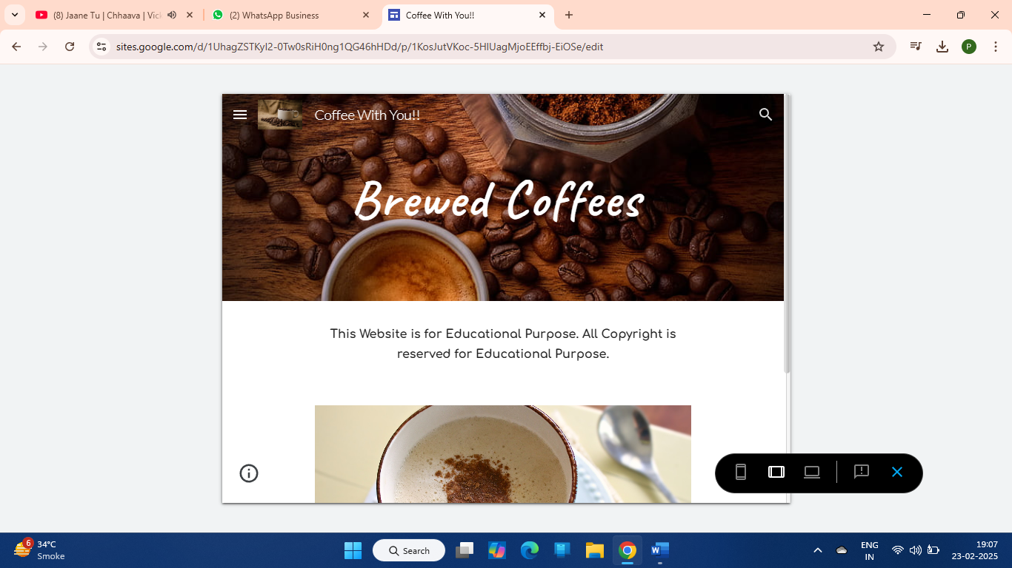

**Aim: Demonstrate the use of Clicky Platform.**

**Website: Clicky.com**

Clicky is a real-time web analytics platform designed to track and analyze website traffic and user behavior.

This data from Clicky’s demo site shows traffic metrics and trends for a particular period, likely from the end of January to early February. Here's an analysis of key components:

1. **Traffic Overview:** It provides a high-level view of how much traffic your site is receiving.

**Visitors:** The site saw 106 visitors, which is a 30% decrease compared to the previous period.

**Actions:** 160 total actions (clicks, views, etc.), a 32% decrease.

**Average Actions per Visitor:** 1.5, which is slightly down by 6%.

**Time on Site:** Total time spent on the site is 5 hours, 5 minutes, and 5 seconds, which is a 24% decrease. However, the **average time per visit** increased by 30%, suggesting that when users do visit, they are spending more time on the site.

**Bounce Rate:** 42%, a decrease of 14%, meaning fewer visitors left after viewing just one page.

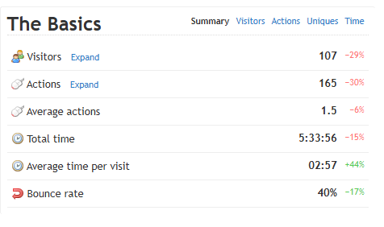

**2. Uptime:** Uptime measures whether the website is available and functioning properly.

* The uptime is 100% both for Clicky and Google services, ensuring that the site is reliably accessible.

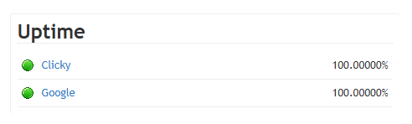

**3. Visitor Breakdown (by country and city):**  It segments your visitors by country, city, language, organization, and host.

* **Top countries:** United States (29 visitors), India (12), Russian Federation (10), the United Kingdom (7), and Iran (5).
* **Cities:** The top cities have not been specified but are included in the "Most Active" visitor section, with India, Mexico, Singapore, and the US standing out.

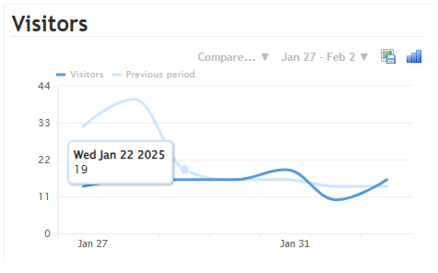

**4. Traffic Sources:** It tells you where your website visitors are coming from.

* **Direct Traffic:** 35 visitors, which has slightly decreased by 3%.
* **Advertising:** 31 visitors, down by 33%, possibly reflecting fewer ads or ad impressions.
* **Searches:** 30 visitors, which is 21% lower than the previous period.
* **Links:** 10 visitors, showing a sharp drop of 68%. This suggests a decrease in referral traffic.

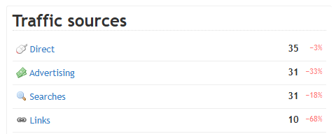

**5. Content Performance:** It shows which specific pages on your site are being visited the most.

* **Top Pages Visited:**
  + The homepage and proxy-related content are the most visited pages, with notable articles like "Mobile App Design Trends" and "Anti-Adblock Tracking."
  + Other pages, such as the "Big Update for Trends and Graphs," saw significant increases in traffic (+600%).
* **Page views have declined** for some pages, notably those related to cookies and privacy tracking, indicating changes in what users are most interested in.

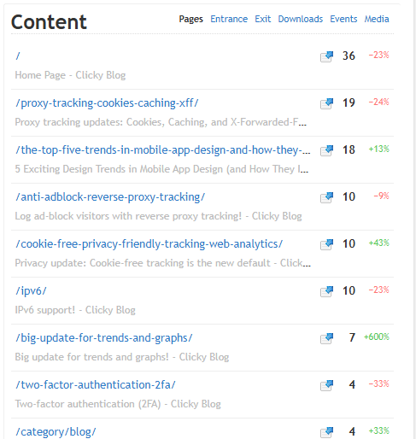

**6. Geography of Traffic:** It breaks down your audience by geographic location (country, city, etc.).

* The United States leads in visitors, followed by India, Russia, the UK, and Iran, highlighting a diverse international audience.
* The surge in traffic from countries like the UK (+250%) and Iran (+150%) might be due to specific interest in content, such as proxy-tracking or privacy-related topics.

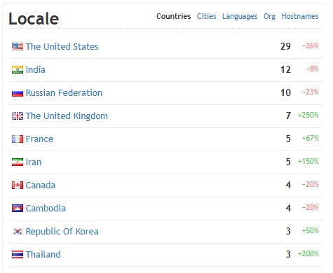

**7. Platforms and Browsers:** It tells you which platforms (mobile, desktop) and browsers (Chrome, Safari, etc.)

* **Google Chrome** is the most common browser, with the 132.0 version seeing the most visits.
* **Mobile Devices**: Mobile traffic is growing, especially with mobile Chrome (132.0) and Safari (18.2) versions showing increased activity, with mobile usage up by 114%.
* **Edge and Unknown Browsers** also show increasing shares, highlighting a potential shift in browser preferences.

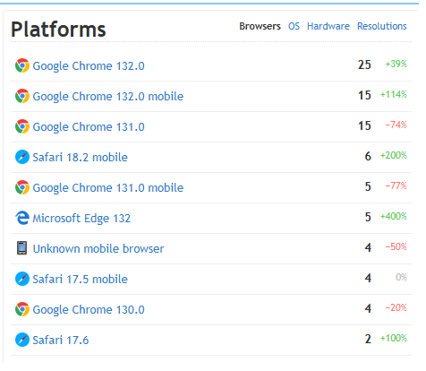

**Summary**

* The site is experiencing a decline in overall visits and actions but seems to retain higher engagement with visitors who do come, as shown by the increase in average visit time.
* A notable drop in traffic sources, especially from links and searches, suggests that some marketing channels may not be as effective as before.
* Geographically, the United States is still the top traffic driver, but there's a noticeable increase in visitors from regions like the UK and Iran.
* There's growing mobile traffic, which could indicate the importance of optimizing the site for mobile devices.

**Class: SYIT Sem: IV Roll No.: SYIT28 Date:**

**Course Name: Digital Marketing using Google Analytics Page no:**

**Practical Number:- 07**

**Q. Illustrate the use of Google Analytics to track performance of a Ecommerce website.**

**Steps:**

**Step 1:** Access Google Analytics Demo Account.

Link the GA Demo account with your Google Analytics 4 platform. <https://analytics.google.com/analytics/index/demoaccount?appstate=/p213025502>

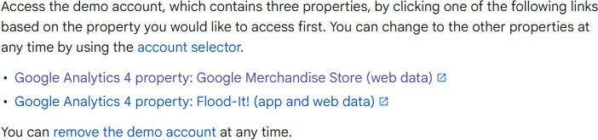

**Step 2:** Navigate to E-Commerce Reports.

* In your GA Dashboard you will see a menu with icons on the left. Click on the Reports tab and Locate and

open the **Monetization → E-Commerce Purchases** report.

* Scroll down to the table section of the report and change the dimensions from Item Name to Item Brand.
* Click on the plus icon and select a dimension from the given list. Take a screenshot of the new details.
* Do the same for Promotions and Transactions Tabs.

**Ecommerce Purchases:**

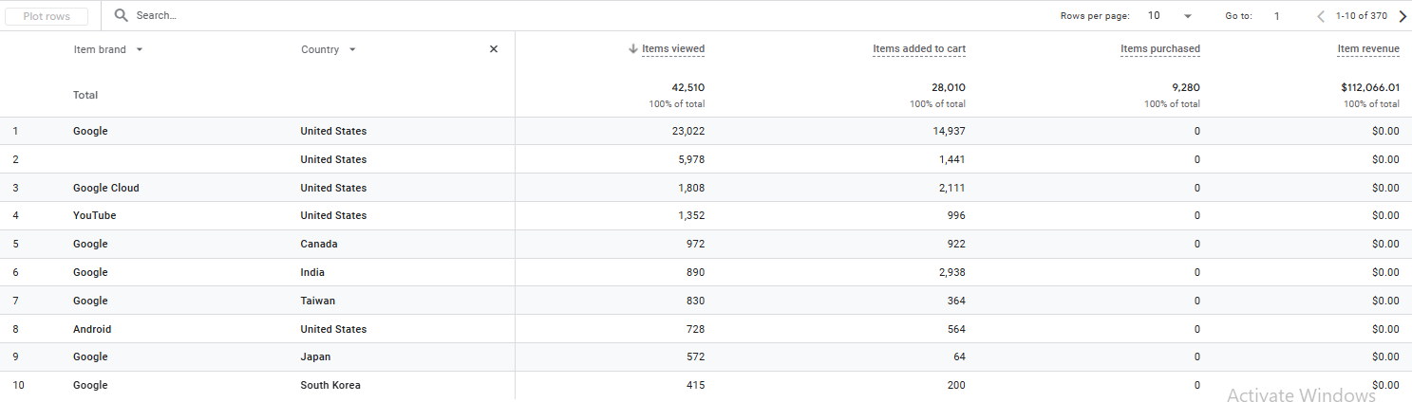

**Class: SYIT Sem: IV Roll No.: SYIT28 Date:**

**Course Name: Digital Marketing using Google Analytics Page no:**

**Practical Number:- 07**

**Promotions:**

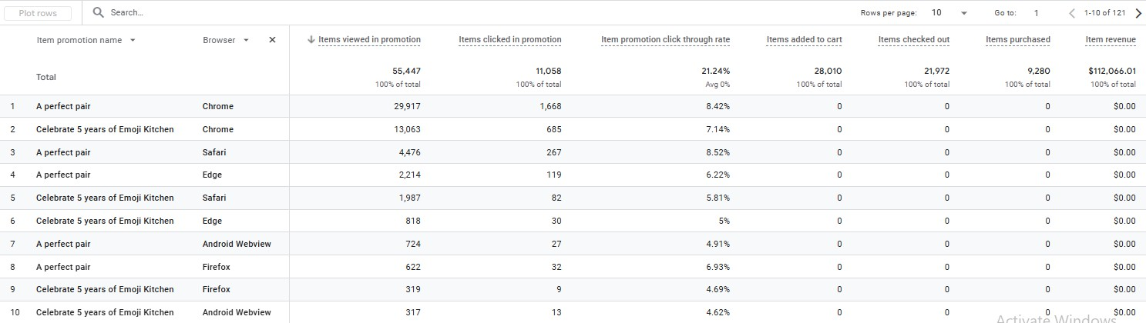

**Transactions:**

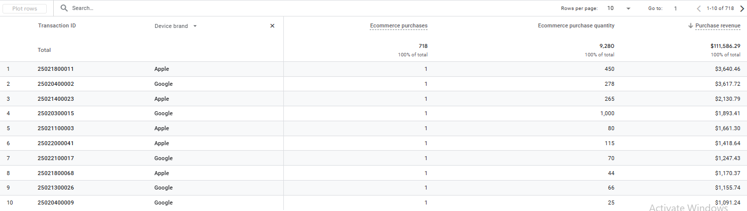

**Step 3:** Identify Key E-Commerce Metrics from the data you saw in the above tabs. In this context you have to select the metrics you think plays an important role for your business. For Example: Items Purchased and Item Revenue.

* Calculate the Average Purchase Revenue per User by using the formula Average Purchase Revenue per User = Total Revenue

Total Purchase

* You have checkboxes in front of you click on the product you want to track and click on the Plot row button. You will see the graph above change according to the rows you clicked.

**Class: SYIT Sem: IV Roll No.: SYIT28 Date:**

**Course Name: Digital Marketing using Google Analytics Page no:**

**Practical Number:- 07**

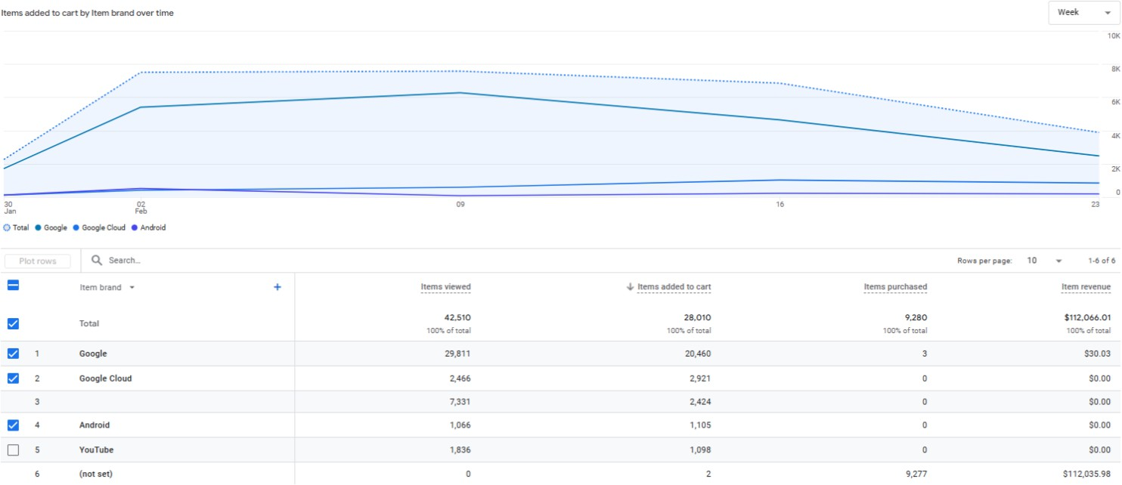

**Step 4:** Analyze Product Performance. Identify the **best-selling product** and it’s total purchases.

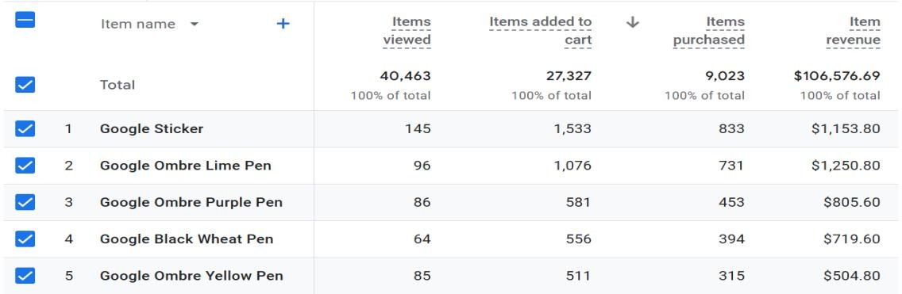

**Step 5:** Analyze Traffic Sources. Extract data from the **Traffic Acquisition** report to determine:

1. The top traffic source (Organic, Paid, Social, etc.).

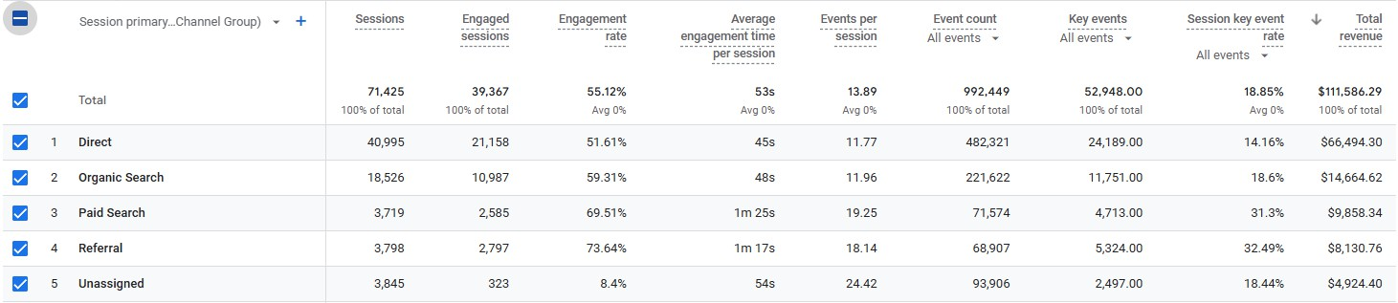

**Class: SYIT Sem: IV Roll No.: SYIT28 Date:**

**Course Name: Digital Marketing using Google Analytics Page no:**

**Practical Number:- 07**

1. The source with the highest Engagement rate.

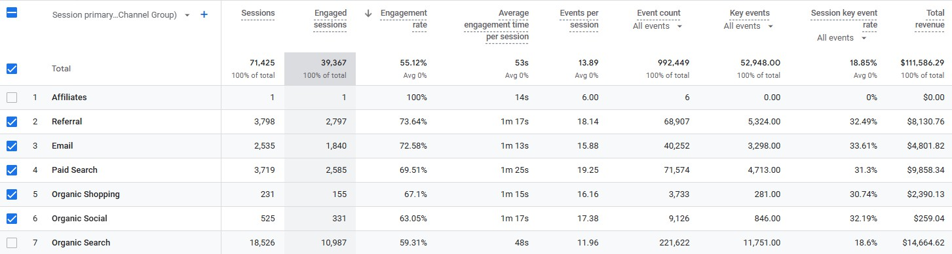

**Step 6:** Compare New vs. Returning Customers. Use the **User Retention** report to check the percentage of returning users vs. new users.

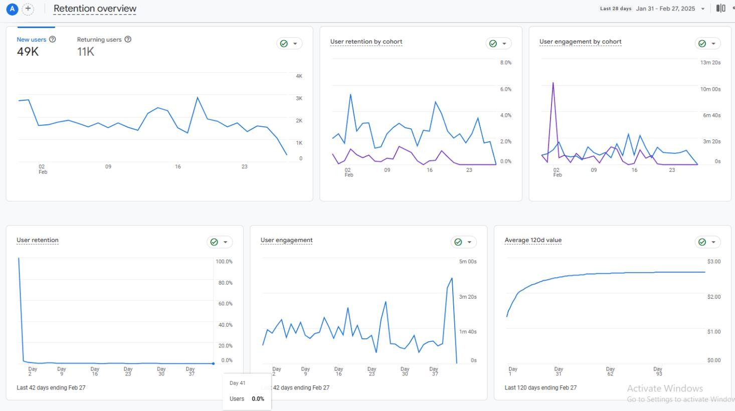

**Class: SYIT Sem: IV Roll No.: SYIT28 Date:**

**Course Name: Digital Marketing using Google Analytics Page no:**

**Practical Number:- 07**

**Step 7:** Provide 3 Optimization Suggestions.

1. Improve High-Performing Product Visibility
   * If a particular product is selling well, promote it further using targeted marketing campaigns, discounts, or homepage placements.
   * Consider bundling it with other products to increase the average purchase value.
2. Optimize Traffic Sources for Better Engagement
   * If organic search is bringing the highest traffic but paid ads have better engagement, adjust your paid campaigns to focus on keywords and audiences that align with engaged users.
   * Increase content marketing efforts (SEO, blog posts) to boost organic traffic further.
3. Enhance Customer Retention Strategies
   * If new users have a higher bounce rate compared to returning users, improve the first-time user experience with better landing pages and onboarding.
   * Implement loyalty programs or personalized email campaigns to encourage repeat purchases.

**Class: SYIT Sem: IV Roll No.: SYIT28 Date:**

**Course Name: Digital Marketing using Google Analytics Page no:**

**Practical Number:- 08**

1. **Demonstrate Report Generation in Google Analytics.**

**Steps:**

**Step 1:** Access Your personal blog account that you created in the first practical and link it with GA platform.

**Step 2:** Create an Event

* + In your GA Dashboard you will see a menu with icons on the left. Click on the Setting icon at the bottom of the menubar (Admin).
  + In Data Display > Events > Create Event > Event
  + Write a new name for your Event eg Test_demo
  + In GA4, you can create a custom event that triggers when an existing event meets ALL specified conditions. Give a parameter that will serve as the existing event.
  + Set the operator (equal, not equal, etc)
  + And the value that triggers it.

**Example: Track Purchases Over $100**

|  |  |  |
| --- | --- | --- |
| **Parameter** | **Operator** | **Value** |
| event_name | equals | purchase |
| value | greater than | 100 |

**Example: Track Video Plays Only from Logged-In Users**

|  |  |  |
| --- | --- | --- |
| **Parameter** | **Operator** | **Value** |
| event_name | equals | video_start |
| user_logged_in | equals | true |

**Class: SYIT Sem: IV Roll No.: SYIT28 Date:**

**Course Name: Digital Marketing using Google Analytics Page no:**

**Practical Number:- 08**

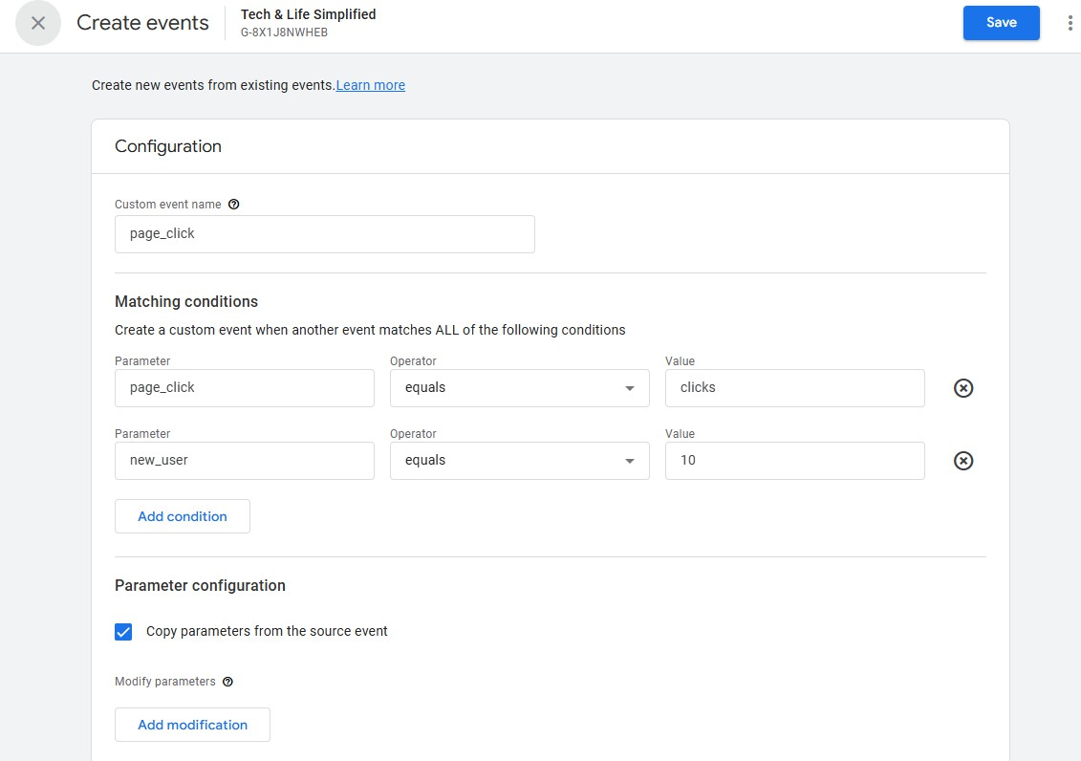

**Click on Create**

**Step 3:** Before creating a funnel report, make sure GA4 is properly set up on your Blogger site.

1. Go to Blogger Dashboard → Settings → Analytics Property ID.
2. Enter your GA4 Measurement ID
3. Save the settings and ensure GA4 is collecting data.

**Class: SYIT Sem: IV Roll No.: SYIT28 Date:**

**Course Name: Digital Marketing using Google Analytics Page no:**

**Practical Number:- 08**

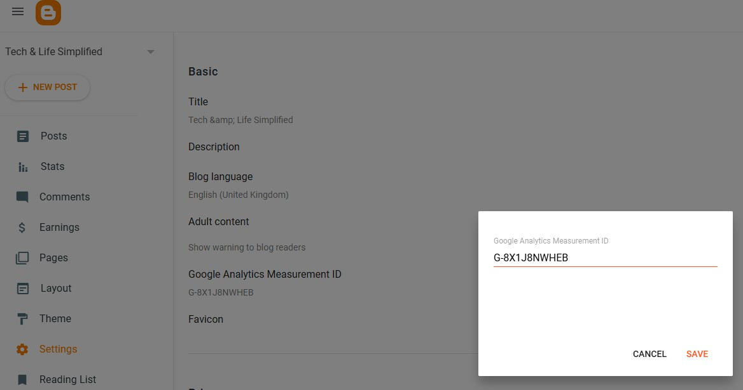

**Step 4:** Now go to Explore Section to create a custom Report.

* + Click on Funnel Exploration.
  + In the Settings section, under Steps, click "Pencil icon".
  + Remove all existing steps and create your own.
  + Name the step (e.g., "Visit Blog Homepage").
  + Click "Add New Condition" → Select "Event name" → equals → session_start".
  + Add Step 2: "Read Blog Post" → Event name = page_view.
  + Add Step 3: "Scroll 90%" → Event name = scroll, Percent_scrolled = 90.
  + Set the time period (e.g., last 30 days).
  + Add a segment if you want to track specific users (e.g., mobile vs. desktop).

**Class: SYIT Sem: IV Roll No.: SYIT28 Date:**

**Course Name: Digital Marketing using Google Analytics Page no:**

**Practical Number:- 08**

